To plan or not to plan?
Most practitioners would agree that it is imperative to plan your lessons. Ur (2012) maintains that writing things down can clarify thinking. Harmer (2015), however, notes that the level of planning required is individual, and the type of plan chosen will vary. Harmer goes on to say that not knowing what you want students to achieve (i.e., not having planned) can lead to unfocused and poorly organised lessons. There is a downside to planning though, and this is what Harmer terms the 'planning paradox'. Czikszentmahalyi (2013; cited in Harmer, 2015) believes that detailed planning can be a barrier to responsive teaching. For example, an overzealous execution of a plan can be restrictive. Underhill and Maley (2012; cited in Harmer, 2015) refer to the 'dark matter' of the class (those events which cannot be predicted), observing that lessons rarely go as planned.
This is the nature of the planning paradox. Planning is good, but it can be restrictive if we adhere to a plan too rigidly. It can lead to the teacher ignoring something unexpected, such as a conversation that develops into something fascinating, or a topic that arouses a lot of interest. Or even some fabulous and exciting vocabulary that would benefit the whole class. The same could apply to a problem which occurs unexpectedly in the class.
A further paradox arises in the 'process vs product' debate about planning. Teachers need to decide whether the focus of the lesson should be on achieving some end point (the product) or on the processes that will facilitate language learning during the lesson (the process).
Despite the dilemmas around planning, the consensus is that lessons do need to be carefully considered in advance to ensure their efficacy.
You may find it useful to refer to Unit 4 for the debates about grammar teaching and Unit 5, where the debates about teaching each skill are covered.
To ensure a structured and reliable plan, there are a number of points to be considered. Please note that this is not an exhaustive list and is only intended as a guideline.
See the following titles for more information:
What is the specific teaching point or target language?
- This refers to the specific language to be taught. Ask yourself whether it is a grammar point, lexis, or pronunciation class and what students should know by the end of the session (product).
- This refers to the specific skills that the lesson needs to focus on. Is it a listening, speaking, reading, or writing lesson? Are these skills segregated or integrated (e.g., will you do some of more than one skill)? What should the students be better able to do at the end of the session (process)?
What is a good way to set the context?
- Think back to our previous unit, where we discussed activating the schemata and the importance of context. What will you do to establish some context? Will you use dialogue, description, realia, pictures, mime, story, or questions (for example)?
How are you going to highlight the language?
- You could tell them – this would align with a more deductive approach and PPP methodology.
- Or you could ask them to discover it – this would align with a more inductive approach.
What activities will you use?
- Consider your activities and the order in which you will use them. Think back to the previous unit about staging the lesson.
- Consider the timings for each activity.
What materials?
- How much freedom do you have over this?
- Will you be using a coursebook?
- Will you be devising your own materials?
What opportunities for practice will you provide?
- Consider how to maximise student talk time (STT).
- Consider how to maximise interaction.
How will you engage the learners at the beginning and throughout?
- Will you use a warmer? Icebreakers?
- Consider how to vary interaction patterns.
- For example, consider a good variety of pair work, group work, whole-class engagement, and individual work.
How will you manage the class?
- Consider the clarity of your instructions between interactions.
- Consider how you will use seating to facilitate your activities. Will you use a circle or a horseshoe seating arrangement? Some more examples of possible seating arrangements are shown below (adapted from Scrivener, 2011).
Figure 6.1: Examples of possible seating arrangements
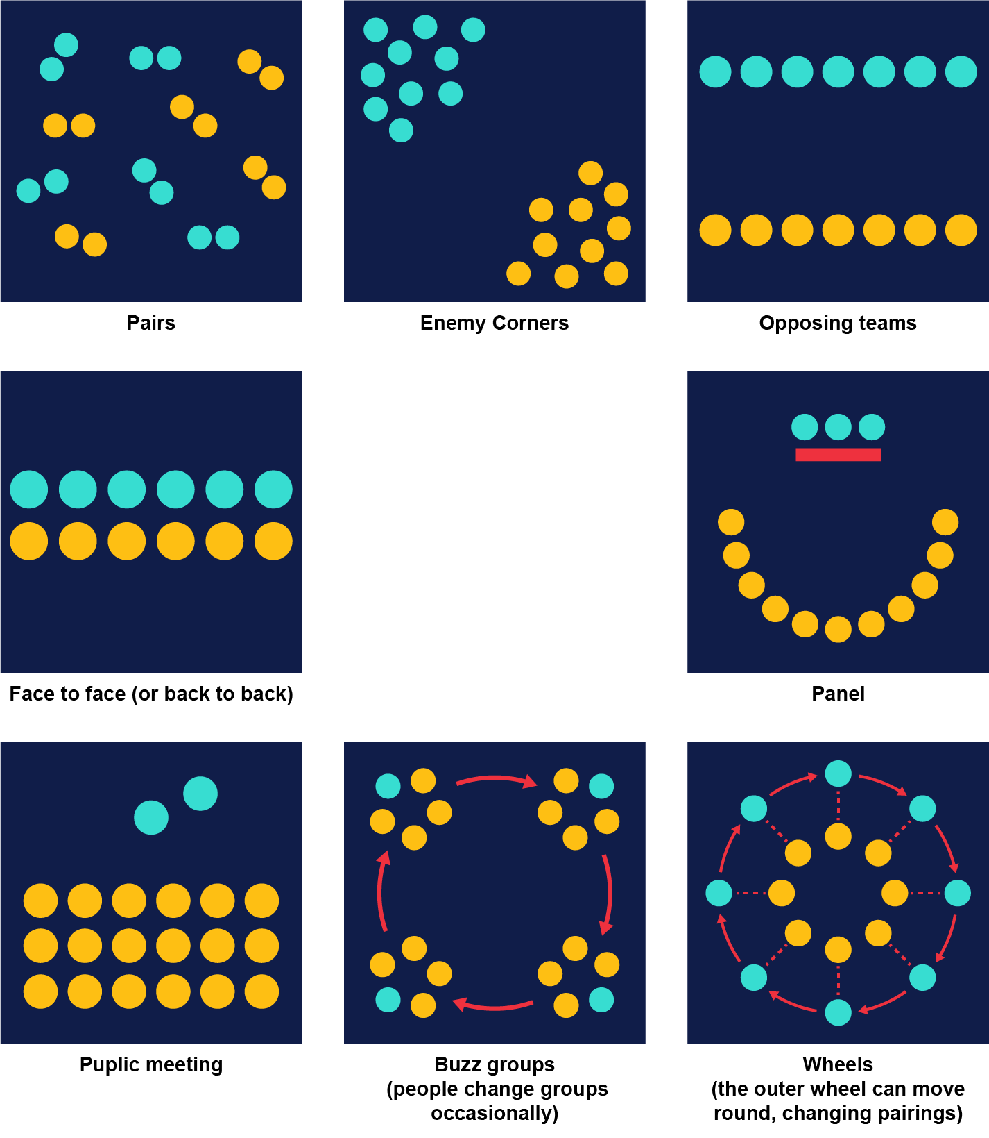

Image source: Scrivener (2011)
What difficulties do you anticipate, and can you generate solutions?
It is important to anticipate, as far as possible, any questions that the students may have. This is especially true in grammar teaching, where new teachers may feel that they do not have all the answers. The best defence to this is to predict student questions and prepare your responses. Failing that, it is acceptable to say that you do not know and that you will get back to them with an answer.
If you are basing your assignment on Scenario A (planning and delivering a workshop), you can now begin to think about your lesson plan for the summative assessment and ensure that you can answer the questions listed above. Having a solid plan for your workshop will help you to structure your reflective report for the summative assignment. However, it's important to note that the plan itself will not be assessed.
Now we have considered the importance of the lesson plan, we will turn our attention to the assignment.

