The productive skills

We will now focus on the productive skills of writing and speaking and think about the issues and considerations arising when teaching these skills.
Before we start to discuss what writing actually requires from learners and what issues they may struggle with, first take a minute to think about any learners you know and the type of writing expected of them. These could be learners from your present context or a previous one. What sort of things were they expected to write and how did they cope with this? What problems did they experience?
Make some notes in your Personal Journal. Write no more than 150 words.
What is writing?
See each of the following characteristics outlined by Ur (2012).
Figure 5.1: Features of language
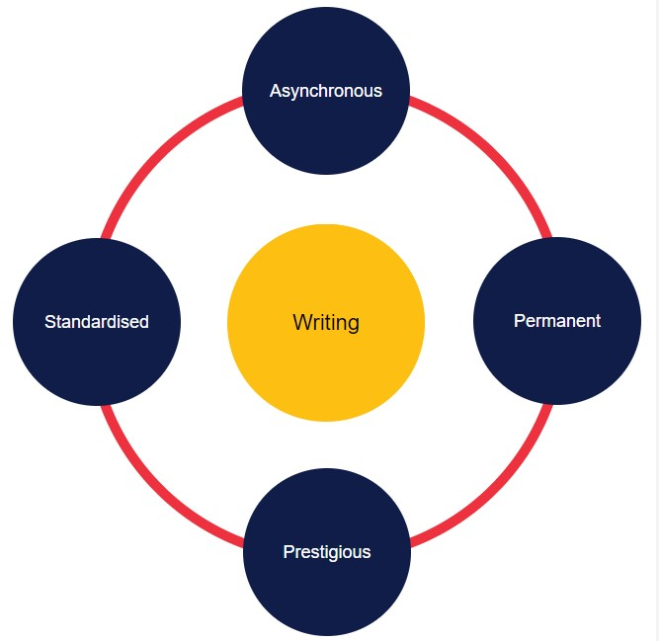

Image source: University of Derby (2023)
Asynchronous
Writing is asynchronous – that is, time independent. The people being addressed are not present.
Permanent
Writing tends to be produced slowly with opportunities to draft and redraft, and it has a permanence.
Prestigious
It is a learnt and high prestige form. Spoken language is acquired intuitively, whereas the written form has to be taught. In modern society, it has a sense of prestige, as literate people are more respected.
Standardised
Another aspect which distinguishes writing from the other skills is that written English tends to use more standard grammatical and lexical forms, although text-speak and computer jargon may be contributing to a change in this more recently.
These features set writing apart from other skills and mean that it has a unique set of considerations for the L2 classroom. We will discuss some of these considerations in the next section.
Formal or informal
Whether writing is considered formal or informal may have an impact on students. They need time to ensure that their writing meets the conventions of an appropriate style.
There are important distinctions. Take a moment to consider how grammar and lexis, spelling, and punctuation may differ between formal and informal styles.
Table 5.1: Features of formal and informal writing
Features of language | Formal writing | Informal writing
Grammar and lexis | standard grammatical rules | may not use standard grammar and lexis (e.g., contracted forms and colloquial terms)
Punctuation | standard rules | punctuation is used less or omitted altogether
Spelling | standard spelling | may use abbreviated forms, such as in text speak (e.g., 'ru gonna go 2nite')
Image source: University of Derby (2023)
Levels of formality mean that your learners will have to make choices about how they write, and they may need further guidance with this. For example, it may not immediately be obvious that contracted forms ('don't' vs 'do not') are considered informal.
Approaches to teaching writing
The approach to be followed in the writing classroom also needs to be considered. Teachers make decisions based on the required goal of the writing task. Select each of the following tabs for information about different approaches.
Fluency in writing
When we think of fluency, it is more often than not in the context of speech. You are probably thinking of smooth, fast speech. However, fluency in writing is something that practitioners should also take into consideration. Tasks that promote fluency in writing are designed to enhance students' ability to write texts for communicative purposes, and they do not focus (primarily) on grammatical accuracy. They are appropriate for certain genres and task-types, and the writer's voice is particularly important.
Harmer (2015) suggests that, to encourage writing fluency, we should encourage students to write as much as they can for a given amount of time. These are termed 'quick write' activities (Millet, 2008; cited in Harmer, 2015). It was thought that such activities improved writing range and speed. Gabrielli (2013; cited in Harmer, 2015) gave students a time limit and encouraged them to write without stopping until the time had elapsed.
Would you use any of these methods with your students to encourage them to write more fluently?
We will focus more on fluency in the following section on speaking.
Speaking

Now let's turn our attention to the speaking classroom and the debates which will inform your pedagogical decisions there.
Goals and considerations
In the speaking classroom, there are various tools to encourage the best from our learners. The speaking classroom can be contentious, as certain students may be unwilling to speak, while others may dominate discussions. Consideration of the task-type is key to ensuring that the focus remains on speaking and that the lesson does not become a grammar lesson, for example.

