I must submit a CIPS assignment. The topic is Sourcing Essentials in Procurement and Supply.

The Task is asking me to

- identify FOUR sourcing approaches. But careful not to fall into the trap of talking about Open Tendering, Restricted Tendering, Competitive Dialogue and Competitive Procedure with Negotiation as sourcing approaches, because this is not what is meant, as they are procedures not approaches.
TUTOR NOTES :You are expected to identify the following - multiple, single dual , sole sourcing, providing a brief insight of each one. Pros and cons can be shared along with a few real world examples where they might have been applied successfully.
single sourcing
Benefits - saving time when we procure ; opportunity to improve quality ; eliminating unnecessary processes in the sourcing process ; opportunity to establish long term relationships with the supplier; savings through qty discounts ; can support your operation through a vendor managed inventory programme ; it becomes much easier to standardise your requirement with the supplier
Drawbacks - the potential for complacency can develop ; since its a single source, you could be exposed to supply chain vulnerability ; supplier and buyer might lose touch with changing market prices and products ; the risk of vendor not delivering on time with no alternatives to depend on
multiple sourcing
Benefits - wide range of options for buyers ; increased buyer leverage ; easy to drive prices down ; increases competition ; easier to explore the market ; benefit from competitive rivalry as well when suppliers try to out price or out perform each other ; much useful model in times of disasters or supply chain crisis : See link for additional benefits : https://www.forbes.com/sites/stevebanker/2020/05/01/if-multi-sourcing-is-a-best-practice-why-are-so-few-companies-doing-it/?sh=6eae8f126121
Drawbacks - could be extremely burdensome from an administrative perspective in terms invoicing , audit, placing orders , issuing RFQs , following up on deliveries etc . ; have to communicate with many suppliers instead one ; does impact your supplier management system ; no opportunity for innovation ; no opportunity for standardisation ; difficult to track spend with varying prices quoted at an given time
Sole sourcing
Benefits - even though you might be constrained to one supplier , there is still an opportunity to build a win win long term relationship, simply because, the buyer may also have leverage as being one of the few buyers who supports the suppliers business ; if the business relationship remains collaborative , then buyers would benefit from concessions ; shared risk between them and supplier, innovation and working closely to improve quality
Drawbacks - in the case of having to switch from one supplier or sole source provider to another with a different technology , specification etc, the buyer is likely to incur significant cost and so to the supplier ; with a strained relationship the supplier can exploit the buyer with high prices ; if the supplier becomes insolvent this can directly impact the buyer's operation
Dual sourcing
Benefits - there in an opportunity for the two chosen suppliers to compete against each other. This competitive rivalry will benefit the buyer ; having an alternative option will reduce some risk ; both suppliers can also standardise their specification to suit your requirement
Drawback - even though another provider shares the supply of goods or services , there still exists the risk of shortages , complacency, and not getting the best market price at a given time

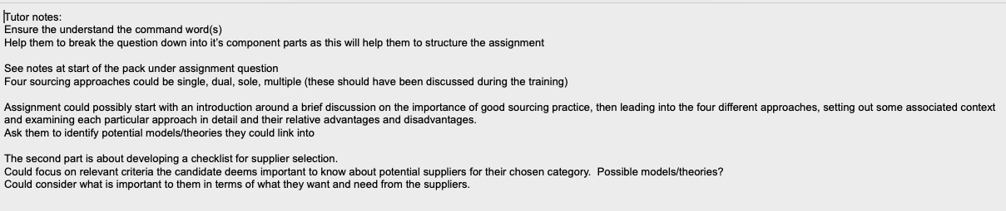
CIPS Advice below:

- For each one Identify and explain how you apply them to a category of spend within my organisation.

- What category / categories of spend will you use? for example is it high value or low value , direct indirect procurement items , strategic or non strategic ? is it capital spares or routine spares ?
- here are a list of spend categories : stationery ; advertising spare parts , capital spares ; direct procurement ; indirect procurement ; strategic ; routine ; services ; types of oil ; MROs etc

- Which models could you use to provide context to the category? in terms of model to help develop the context here, the Kraljic matrix can be considered here as it distributes purchases based on values and importance. You can also consider the ABC analysis which distributes spend and volume of suppliers. So mention in your report how these tools could be used in determining which sourcing approach is required for which category

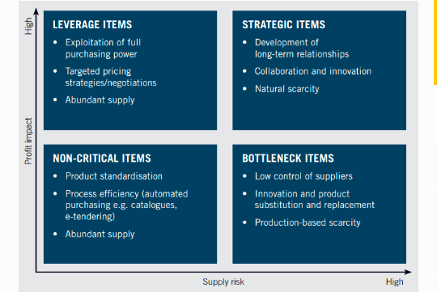

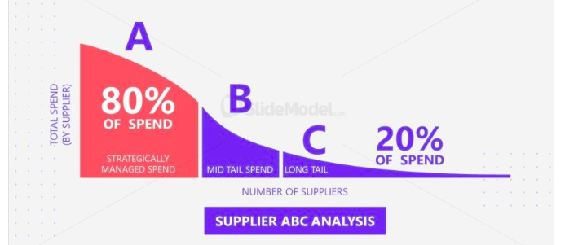

- Is it a strategic requirement? How might this impact on the sourcing approach you choose? TUTOR NOTES - here, you would want to discuss not only the impact on strategic items but other categories of spend as well. Here's another tip. let's say a sole sourcing approach is adopted for capital spares and machinery, then there would be need for a collaborative relationships, supplier relationship management and stakeholder management to manage risks throughout the contract.

- What type of relationship might be appropriate with the supplier? How will this impact on the sourcing approach you choose? This was partially discussed above. However, you are encouraged to explain a few relationship approaches and justifying why you have chosen the one you felt was most suitable for the sourcing approach.

- Which models will help you to understand the number of suppliers and the level of competition in the marketplace? TUTOR notes - there are a few models you might want to explore here . Porter's 5 forces is useful to determine leverage and competition in the market. An analysis by STEEPLED can also help here. Share them and explain how they can help you source intelligently. For example, the Economic element of STEEPLED could disclose whether or not there is a monopoly globally for a product or service. Model for use : Porter’s 5 forces and STEEPLED as pictures below:
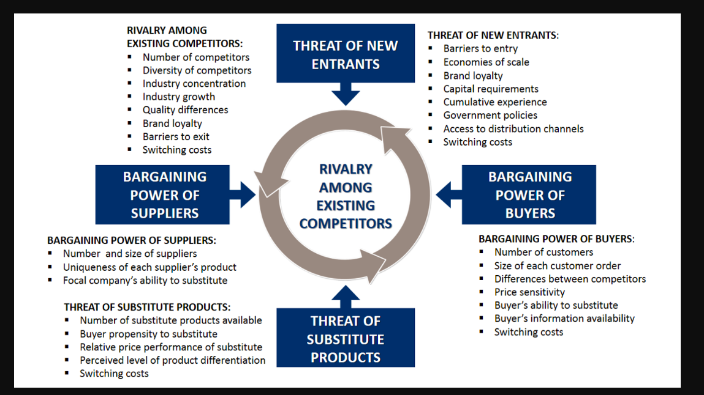
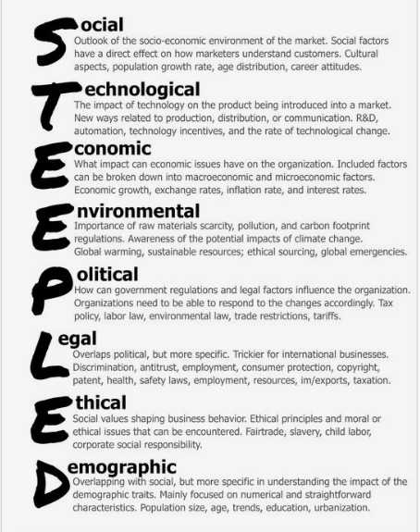

- How will this help you to determine which sourcing approach is appropriate?Is the marketplace a monopoly / oligopoly / perfect competition? TUTOR NOTES - based on the information provided with the help of the models above, if a monopoly exists for some goods, or the acquisition of future goods, then, a sole sourcing approach is likely to be the only choice for your business. This is just one example. In another example, in a perfect competition scenario with many buyers and sellers, you would be more inclined to go for multiple sourcing. These are the type of discussions you might want to have.

- What are the strengths and weaknesses of each sourcing approach both generally? specifically, when applied to your category? Are there any opportunities for your organisation? What are the threats? What model could you use? TUTOR NOTES - This is more or less straight forward. However, I would encourage you to highlight the long term opportunities when venturing into either of them. For example, both sole and single sourcing have the opportunity to develop partnerships that encourage supplier innovation, shared risk etc Have the same discussion for the other elements of SWOT , which would be the most appropriate tool here

- Choose one of these categories and develop a supplier appraisal check list. Note: remember the difference between selection criteria and award criteria.

- What areas should the supplier appraisal checklist cover? TUTOR NOTES - At the start of your discourse you might want to explain the importance of a supplier appraisal which would include at some point , a checklist. Here, you should clearly identify the areas you think are necessary for your checklist as per the category chosen

- What areas does your appraisal checklist cover? And why?
- Are there any gaps? TUTOR NOTES - In other words, what gap you think your appraisal needs to address and how can this be captured in your checklist ( what questions in the checklist can help address these gaps) NB - If a checklist already exists, how can you improve it. If it doesn't then what would you include if you are developing one

- What impact does this have? TUTOR NOTES - in other words what impact does the changes or addressing the gaps have on the operation or even the supplier's performance ?

- How could you address this? TUTOR NOTES - develop the most suitable question in your checklist. This can be done with the help of your stakeholders.

- Which model could you use? TUTOR NOTES - One of the more suitable models here would be Carter's 10 Cs model which could help identify areas your current checklist may not have included
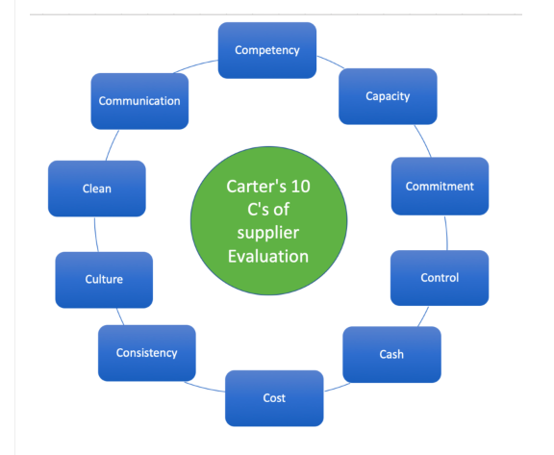
- Are any areas more important that others in the context of the category of spend, and should possibly be weighted? Are there any specific public sector requirements for supplier appraisal checklists? TUROR NOTE - Please use the KRLAJIC MATRIX WHEN DISCUSSING THE CATEGORY OF SPEND AND THIER IMPORTANCE

Note: make sure that you include the relevant question from your supplier appraisal checklist in the main body of the assignment where you are discussing and analysing it.
Note: if as part of your recommendations, you are suggesting a change to your supplier appraisal checklist, consider including the new wording for the question in a table under the relevant recommendation. This will show the assessor that you have identified a gap, made a recommendation to bridge the gap, and shown how the recommendation will be implemented.

So, the above is the assessment Crib sheet. Now below I will write assessment guidance:

Your work should consist of 3,000 words. Your assignment should include the assignment title, your candidate number and word count on the front cover, followed by contents page, executive summary, conclusions, recommendations, references and a bibliography. Any source materials such as web sites, company reports, indices, market data, articles, journals or texts should be listed in your references or bibliography in accordance with a recognised referencing system. Your assignment submission should be word processed with a minimum font size 12pt and 1.5 or double line spacing. Refer to the Assignment Guidance document for more information.
1. This assignment enables you to demonstrate the knowledge and understanding you have gained within the programme, together with your ability to research, analyse and problem solve a range of different procurement and supply related situations and challenges.
2. You are advised to read carefully the complete Assignment Guidance available from the My Learning section on the LMS (Learning Management System) before commencing your submission.
3. You are expected to approach your assignment from a procurement and supply context using the module content as the basis of your submission.
4. It is recommended that you base your assignment upon the business unit or organisation you work for, as it is likely you will be able to access appropriate information and data that you will require to underpin and support your final submission.
5. Your assignment must be your own work. In order to avoid plagiarism, whenever you use someone’s words directly, or make reference to the ideas or work of others, you must reference this appropriately using a recognised referencing system, as outlined in the Assignment Guidance document. Failure to reference the work of others, whether intentional or accidental, is considered plagiarism which constitutes a form of cheating and is not tolerated by CIPS.
6. Your assignment submission will be assessed according to the following assessment criteria (see the complete Assessment Guidance document (LMS – My Learning) for more information): a. Application and insight (40%) b. Research (20%) c. Knowledge and approach (20%) d. Structure and presentation (20%)
7. Plan your assignment to ensure that you have addressed all elements of the assignment task and the assessment criteria, as well as the module learning outcomes. Think carefully about the structure, style and content of your assignment.
8. Please include your CIPS candidate number on each page of your assignment submission and include the total word count of your submission. Your name should not appear on your assignment.
9. Your assignment can be up to 10% below the stated word count, or up to 10% higher than the stated word count. If your assignment exceeds the stated word count by more than 10%, marks may be deducted. The assignment guidance explains what is and what is not to be included in the word count. Your reference list and bibliography is excluded from the word count.
10. Please ensure you hand in your submission no later than the deadline date. There are penalties if your submission is handed in late without prior agreement from CIPS. If your submission is late, your result will be capped at 50%.

The table of content will show you how to structure my assignment

- Executive Summary

- Introduction
Talk about ENEC (my company)
About the assignment (task, breakdown)

- the four sourcing approaches
- intro
- Single supplier sourcing approach
- intro
- category

Sole supplier sourcing approach
- Intro
- Category
Dual supplier sourcing approach
- Intro
- Category
Multiple supplier sourcing approach
- Intro
- Category
- Developing Supplier Appraisal Check list
- Intro
- Supplier appraisal checklist
- Conclusion
- Reference

I want you to start section by section. So we will begin with identify FOUR sourcing approaches. I will upload for you to help
- the tutor notes that I need you to read and use.
- Sample assignment, make sure that you don’t plagiarise. Just use to understand the structure of the assignment.
- I will upload a voice note from the tutor explaining the Crib Sheet.

So as I said. One section at a time.

