CMIT 351 Project 2 Template

Please input the following correctly in the PKA when the PKA file is opened as shown below:

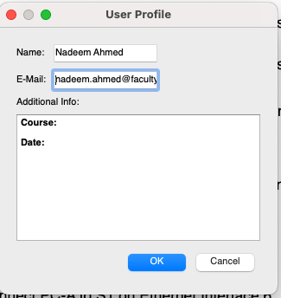

A starter network with labeled devices on the screen is presented already without them connected when you open the PKA file.

After the completion of your configuration in the PKA answer the following items:

- Test and validate connectivity following the instructions and explain why connectivity tests work or fail. (2.5% of total)
To get the 2.5% you are required to use the PC command line to run ping tests for connectivity and paste screenshots of the connectivity tests you ran on the PCs in the PKA after configuration HERE.

Note & Pro Tip: This Packet Tracer Activity has built in connectivity tests that will run once you complete it and show the status and count towards the completion score. Once you have completely configured everything correctly, it will take a minute or two to reach from 97% to 100% as the connectivity tests which are part of the assessment now run periodically and once, they run, it will reach 100%. Also, if you save the completed PKA and re-open it, you will see it at 97% but after a minute or two it will reach 100% and if does not reach 100% click on “Check Results” button and that will force the connectivity tests to run and it will reach 100%

- Describe how you test and validate the VLAN implementation. Do NOT just paste switch configuration but describe in words the commands you may use and why. (2.5% of total)

- Describe how you test and validate the sub-interface implementations. Do NOT just paste router/switch configuration but describe in words the commands you may use and why. (2.5% of total)

- Describe how you test and validate the VLAN Trunking implementation. Do NOT just paste router/switch configuration but describe in words the commands you may use and why. (2.5% of total)

